EXCEPTIONAL VAN GOGH HERITAGE LOCATIONS IN BRABANT OPEN THEIR DOORS FOR A LIMITED PERIOD

19 September 2019, Zundert, Helvoirt, Etten-Leur, Nuenen
During the ‘Van Gogh’s Inner Circle’ exhibition in the Noordbrabants Museum (21 Sep 2019 -12 Jan 2020), the Van Gogh Heritage locations in Brabant will offer a temporary programme featuring the places and stories from Vincent van Gogh’s life in Brabant. From his birth to his first love, the Van Gogh family life and the church: visitors can experience his world at close quarters. Attention is also paid to the Brabant countryside and the buildings that featured in Vincent’s paintings. Some of these will be open especially for this occasion.
Van Gogh’s home ground
Three Van Gogh heritage locations, 39 Van Gogh Monuments and 435 kilometres of cycle routes set the stage in the coming months for an attractive programme based around Vincent’s life and inner circle in Brabant. This starts in Zundert, around the Van GoghHuis where Vincent’s cradle once stood. The Van Gogh Church in Etten-Leur, where Van Gogh started his career as an artist, is a central point. Nuenen, where Van Gogh painted his first masterpiece will expand on this with exhibitions in and around the Vincentre.
Doors will open
Visitors will have the opportunity to discover the most unusual and hidden Van Gogh locations in Brabant in the coming months. The doors of the churches in Zundert and Nuenen, where father Van Gogh was a preacher, will be open for a public programme with presentations and guided tours. It will also be possible at certain times to visit Salon Nune Ville, the house in Nuenen where Vincent’s sweetheart Margot Begemann lived. Local Van Gogh experts will tell their stories at the Van Gogh Monuments and other places that are inextricably linked to the master painter and his family, friends and models.
Vincent van GoghHuis Zundert
The Vincent van GoghHuis in Zundert will present the exhibition ‘Suze Robertson & Marenne Welten – Alongside Van Gogh’. Suze Robertson (1855-1922) was a contemporary of Vincent van Gogh. She was considered to be his female counterpart during her life.
Van Gogh Church Etten-Leur
From 25 September to 22 December, the Van Gogh Church in Etten-Leur will present a photographic exhibition ‘Closer to Van Gogh’. Marc Boom (b. Amsterdam 1968) has reproduced famous Van Gogh portraits in an unusual way. Not by using a brush but with his camera and with real people in the title roles.
Vincentre Nuenen
From 20 September 2019 to 31 March 2020 there will be an exhibition paying extra attention to Van Gogh’s (artist) friends from his Nuenen period, including Dimmen Gestel, Antoon Hermans, Anton Kerssemakers and Willem van de Wakker.
Agenda
All the activities in Zundert, Tilburg, Helvoirt, Etten-Leur and Nuenen are described in detail in the agenda on: vangoghbrabant.com

Editorial note

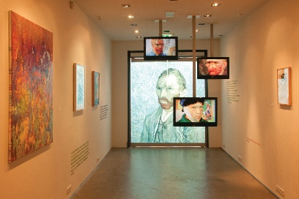 | Roots of a master in Vincent van GoghHuis Zundert  Source: Van Gogh Brabant | 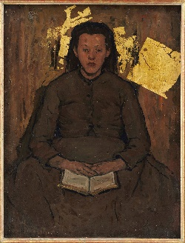 | Suze Robertson, Pietje (young girl at Leur), 1895-1898, oil and gold leaf on canvas, private collection [Photo: Peter Cox)
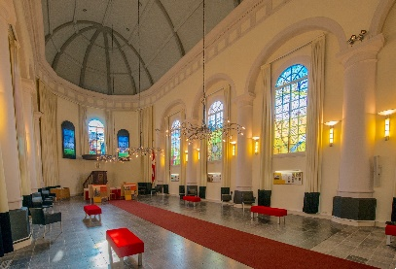 | Van Gogh Church Etten-Leur  Source: Van Gogh Brabant | 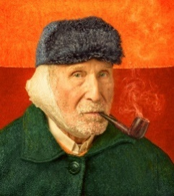 | Self-Portrait with bandaged  ear and pipe`After the painting of the same name by Vincent van Gogh, Arles,  1889 Photo: Marc Boom, 2016
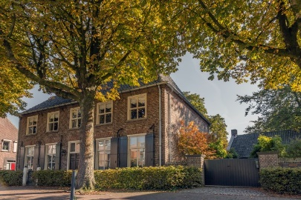 | Rectory in Nuenen, Van Gogh Monument  Source: Van Gogh Brabant | 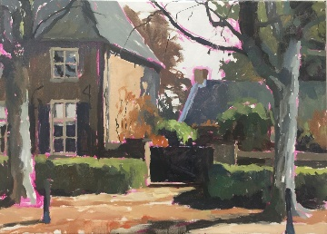 | Galerie Bonnard Artists from Bonnard are inspired by Van Gogh’s paintings: Eric Schutte
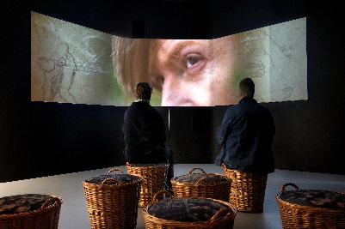 | Vincentre Exhibition  Nuenen  Source: Van Gogh Brabant | 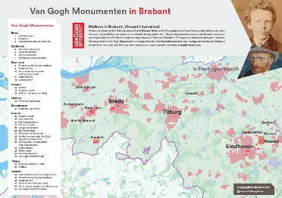 | Van Gogh Monuments Map  Source: Van Gogh Brabant

Van Gogh Brabant: Frank van den Eijnden (director)
frank@vangoghbrabant.com/+31 (0)653630536
Press information and photos: vangoghbrabant.com

About Van Gogh in Brabant
Vincent van Gogh was born in Brabant in 1853. This was the start of his extraordinary talent and his self-opinionated character. It was in Brabant that he developed his love of the countryside and of real people, themes that would recur in all his works. The locations in Brabant where Van Gogh lived and worked have joined forces under the name Van Gogh Brabant (branded as Van Gogh Sites Foundation). The story of his life is told in three heritage centres, 39 Van Gogh Monuments and through a collection of his original works in Het Noordbrabants Museum. Visitors can learn about Vincent, from his childhood years in Zundert to the beginning of his career in Etten, and from his drawing lessons in Tilburg to his first masterpiece in Nuenen.

